Ideation Phase

Define the Problem Statements

|  |  |
| --- | --- |
| Date |  |
| Team ID | LTVIP2025TMID38966 |
| Project Name | GRAINPALETTE |
| Maximum Marks | 2 Marks |

**Customer Problem Statement Template:**

Create a problem statement to understand your customer's point of view. The Customer Problem Statement template helps you focus on what matters to create experiences people will love.

A well-articulated customer problem statement allows you and your team to find the ideal solution for the challenges your customers face. Throughout the process, you’ll also be able to empathize with your customers, which helps you better understand how they perceive your product or service.

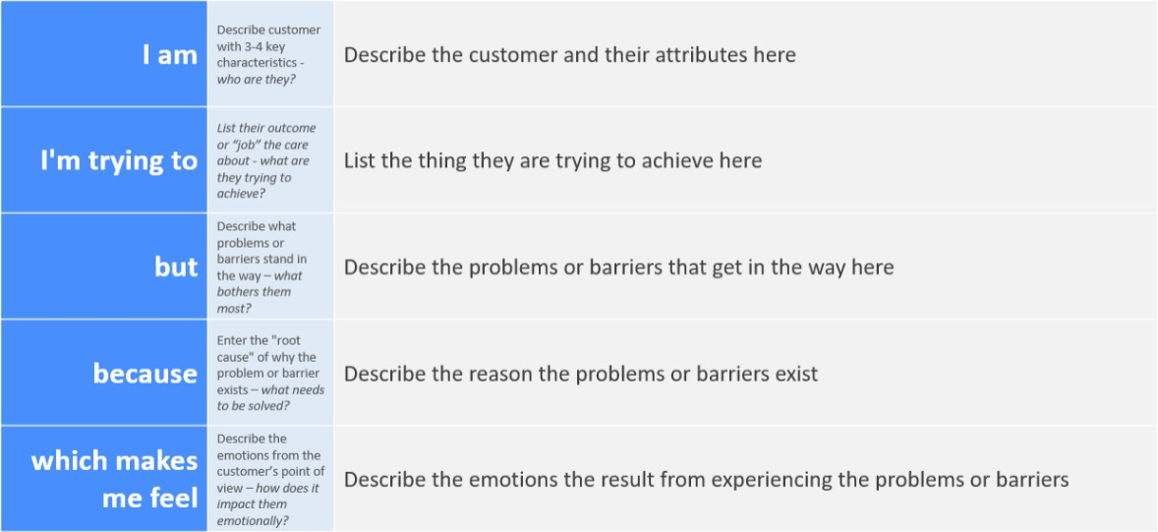

Reference: <https://miro.com/templates/customer-problem-statement/>

**Example:**

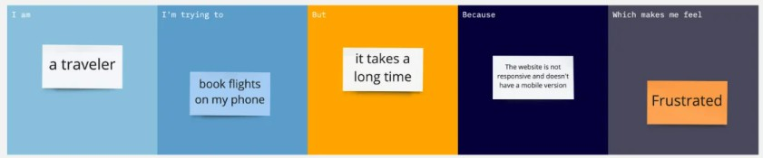

| **Problem Statement (PS)** | **I am (Customer)** | **I’m trying to** | **But** | **Because** | **Which makes me feel** |
| --- | --- | --- | --- | --- | --- |
| **PS-1** | **a farmer or rice mill owner** | **identify the rice variety from my seed stock before cultivation** | **I rely only on visual inspection** | **I don’t have access to expert knowledge or scientific tools** | **uncertain and worried about making wrong decisions** |
| **PS-2** | **an agricultural researcher or quality inspector** | **classify rice grain samples accurately and quickly during field research** | **manual classification is slow and prone to errors** | **traditional methods are time-consuming and not scalable** | **frustrated, inefficient, and unable to scale my work** |